Propane appliances document: https://canvas.uw.edu/courses/1861680/files/folder/PGST%20-%20Data-Meetings-Reports?preview=144000041
- Kitchen in Elder’s Center, small washroom area near gym
- Generator that runs on propane to power site, backup generator system in place
- Start estimating fuel use - use Building Performance Database with building area to determine usage.
- Energy Use Index: energy/square foot/year
  - The climate zone matters!
- The state wants us to do this - replacing propane (fossil fuel) with much cleaner electricity
  - E.g., coal plant in Centralia conflict (federal gov’t not allowing retirement of coal power plants, but the state is trying to decommission)
  - Aiming for carbon-free electricity by 2045 in the state (already pretty close - hydropower, nuclear)
- If we know the efficiency of devices, we should be able to disaggregate a reasonable assumption of what each site is using. Determine how each site is used.

Feasibility and resilience analysis:
- Building Performance Database can estimate fuel usage per square foot.
- Our goal is to do what they ask - if Rachel wants to win grants, we can try to do that to support them.
  - For example, the community center in another one of their projects did not want to get rid of their gas stove.
  - They made a design to replace natural gas forced air heating with a heat pump, not 100% decarbonized but saved some X amount of carbon per year.
- Funders then checked - is this a good deal, meets equity goals, etc. If they don’t want it, design is driven by consequences of different choices (e.g., dimensions of bill savings, energy use, carbon savings, resiliency, outages)
- Cooking with gas - Dr. Schwartz doesn’t know of a program that will buy them a new stove, but he does know of some that would pay for switching to electric heat pump. So the heat pump is a better focus here.
- In terms of generator - solar + storage means they would add in backup energy storage.
- Feasibility study said most of the resiliency would not come from energy storage, but from a propane backup. Way cheaper to store a week of energy in propane, because there is just not that much sun. We will do an analysis to see how much the battery would cost. They can get grants for this battery, but a week is a really long battery backup storage. But batteries are really expensive to replace a week’s worth of energy.
- A battery in the summer could probably go much longer - more sun, not using heating.
- He suggests doing a resiliency analysis around summer solstice vs. winter solstice (darkest/shortest vs. longest days).
- Also shows us what the probability is of surviving a certain length of time (during outage) - could the system make it for X amount of time if there was an outage? Drops off for shadiest days/darkest days.
- Priorities: As an example, for the Jamestown S’Klallam feasibility study, they said keeping food fresh was top priority (frozen and perishable foods good for a minimum of 1 week during the most extreme outages - what % total energy of building, the critical load). Can they meet the critical load?
  - Feasibility study said that the clean energy system could not do this.
- See the PGST Microgrid study in the Canvas folder for helpful info: https://canvas.uw.edu/courses/1861680/files/folder/PGST%20-%20Data-Meetings-Reports?preview=143999956
- One of the values of having us work with them is we have 16 weeks to talk through what goes into deciding this energy system.
  - We will work to understand how constraints we put on design impact its cost and performance. Once we know how to use tools, we will start being able to drive meaningful conversations on constraints of community decisions. Rachel is not a decider - she is a liaison. Tribal elders make actual decisions, but Rachel is important for getting all the pieces to come together.
- If we know how many square feet each of buildings are that use propane, we can use BPD: bpd.lbl.gov (See below notes)

Building Performance Database
- kWh = energy measurement
- kBTUs are a great measure for fuel, not so much electricity
- Energy use index (EUI) in kBtu/sqft/year - measures energy usage per square footage
- Source EUI = the source, raw energy entering the site. Without any of the conversion efficiencies that make it usable energy. Primary energy used to create the secondary energy used on-site normalized by gross floor area. Biggest number.
- Site EUI (usable portion - actually gets used) = total energy consumed on site based on site energy bills. Smaller than Source EUI.
- Electric EUI = just looking at the electricity meter (both grid-purchased electricity and electricity generated on site). Electricity used divided by area of building to normalize by square footage.
- Fuel EUI = all non-electric energy used on site.
- E.g., Total propane used in year -> thousand BTUs -> divide by total square footage

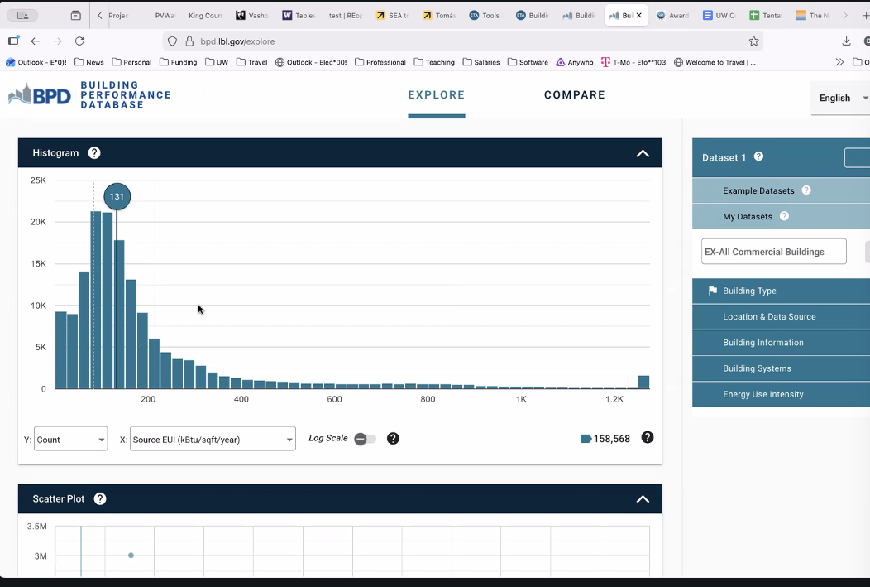
- Median lower than the mean - skewed distribution.
  - To make a reasonable guess, we probably don’t want to use the mean.
- More data for numbers flowing through meters than raw energy data - keep this in mind (see number at bottom right next to blue arrow for number of buildings).
- Note that some buildings have electricity only, numbers vary significantly by building.
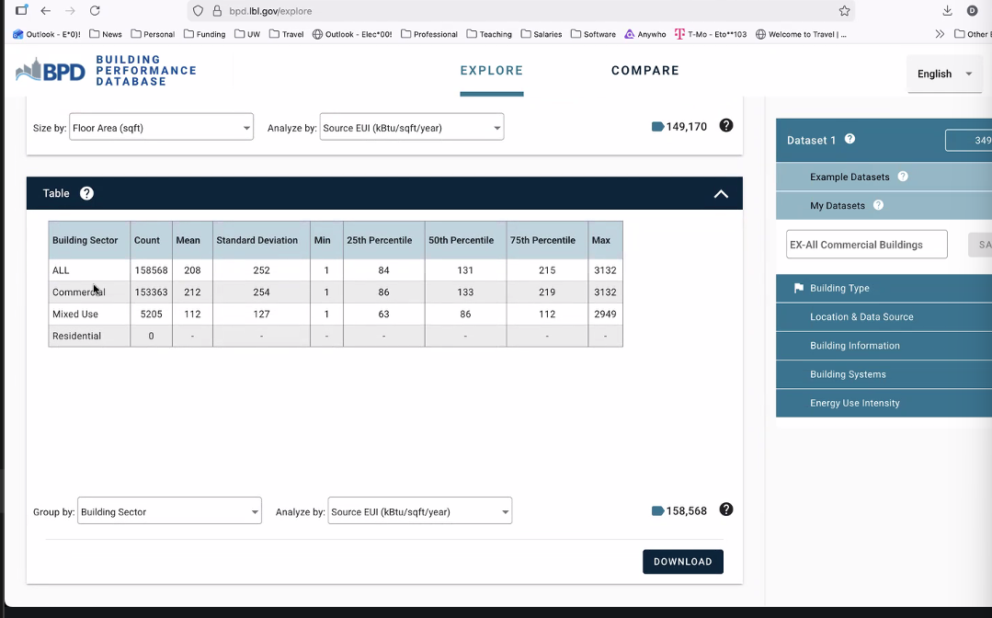
- Commercial and mixed use buildings can include very heavy electric use (hospitals, data centers). We will not be dealing with buildings in the 75th percentile. Ours would be more in the lower range - 25th to 50th percentile or so.
- Group by Climate Zone to filter out different climate areas (this matters):
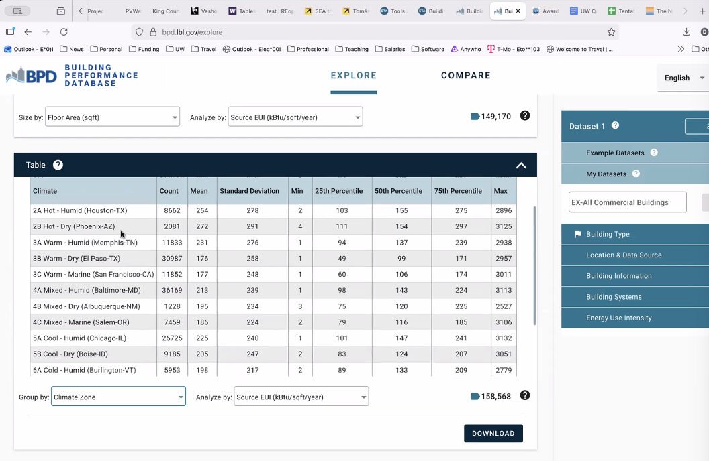
  - Under Climate Zones, the likely building set that is most applicable for us is the 4C Mixed - Marine (Salem-OR).
- Take square footage and multiply it by 12 to get an estimate of how much annual fuel energy is used. Look at how many BTUs there are in a gallon of propane. Boiler has to be at least 80% efficient for any boiler. Start making estimates on how much fuel they use each year.
- What we will get from Rachel are the actual bills - say whether these buildings use more or less than a typical NW building based on our approximate estimates.
  - E.g., Something listed as “heater” - say heating and cooling is about 90% of propane use, stoves and hot water heaters about 10%. Then, what would we guess in terms of usage?
  - Will these buildings get more “bang for buck” than other buildings? What about in the context of a grant?
- There is annual kW data in the feasibility study. Pull out whatever we can about guesses on energy use, carbon intensity.

In a week: Dr. Schwartz wants to see that we have scoured data and used resources. If we want to talk about how we’re doing before Friday - could set up time during office hours, schedule separate time. Since Monday is MLK day, we won’t be meeting but it would be good to try scheduling a check-in.
- Read their carbon plan - they may tell us how much carbon their propane power systems use.
- Start reverse engineering - start identifying, getting an engineering sense of the problem.
- We could ask some questions about requirements - for example, should we be putting EV charging in our design?
- May say there is a 10-year or 20-year planning period, etc. May need to account for EV charging info in our estimates of electrical loads. Look through the carbon plan for this info.
- Potentially meet at office hours, chat through information. Send him a note on time to meet/if going to office hours to discuss.
- Usage has units of kWh and is energy, demand is in power and in kW.
  - There is a reason both are metered - utilities can charge in two ways depending on level of power demand. Size of pipe -> power. If power loads go above 50 kW (or some other limit), they charge for highest power use per month, since they have to build wires according to highest demand.
  - If a building only uses 1 hour in a month, but uses a lot of power in that hour, then the utility charges for that worst hour in the month.
  - Most utility providers have lower limit - if no power over 50 kW, rate only goes by energy used instead of by highest power usage.
  - This is because high power usage means they have to build a big pipe, so the utility will charge according to the highest power. Has a huge impact on the design of the energy system used. Economic incentive to put in the battery behind the meter because they can just use the battery to offset loads and keep the meter always at 50 kW or lower all month long.
  - If always below 50 kW, produce solar whenever usable and offset energy amounts through the meter. Huge economic incentive to do this.
  - Utilities buy energy ahead of time to try to give cheap, wholesale power. Don’t want to buy more than they need (e.g., weather forecasting for cold winter). They do planning and purchasing of power for a month ahead, week ahead, day ahead, and hour ahead but want to buy most of it early - they want to buy as much ahead of time as possible, power purchases get more and more expensive the closer to the time of usage.
  - The real-time market for next-hour needs is very expensive, so it is ideal to buy earlier than an hour in advance.
- Commercial users especially - lots of ways to incentivize lowering cost. Things we learn about cash flow, present value, etc. will underpin our design to do this. Less applicable to residential than commercial.
- In Aspen simulation, we typically don’t worry about power by hour because commodity price per feedstock is not being bought an hour ahead - it is usually a month, two months, half a year out. In typical ChemE systems, they are not buying things in real time. But when looking at electricity, real-time purchase costs are really important to think about since weather/conditions can change unexpectedly.

